Structural Engineering Guidance No. 20-01

Date: February 14, 2020
Distribution: All Engineering Resources
SUBJECT: BRIDGE CONCRETE BARRIER SELECTION GUIDANCE FOR MASH IMPLEMENTATION
Contact: Darren Kemna/Tyler Lindsay
EPG Status: In-Work
Std. Drawing Status: In-Work
Effective Date: Immediately for Jobs in Preliminary Phase
Expiration/Duration: Active until Incorporated into EPG and Bridge Standard Drawings

C O N T E N T S:

Sections
- Background and Purpose
- Guidance for Barrier Selection
- Additional Guidance
- Future Guidance

- Background and Purpose:

To be found eligible for Federal-aid funding, new roadside safety devices should meet the crash test and evaluation criteria contained in the American Association of State Highway and Transportation Officials’ (AASHTO) Manual for Assessing Safety Hardware (MASH). Since neither FHWA nor AASHTO has a system in place to approve roadside devices, the responsibility is left with the States. In response, MoDOT has developed a MASH Implementation process. All roadside devices, including bridge barriers, that are submitted after November 1, 2019¹, will be reviewed by the MASH Team for approval to use on Missouri roadways. Bridge barriers will be approved for TL-4 or TL-3 test levels in accordance with the MASH 2016 standards. The current required MASH 2016 test level for bridges on the National Highway System (NHS) is TL-3, but the expectation is that the TL-4 requirement will be mandated in the next publication.

The purpose of SEG 20-01 is to provide guidance for selection of concrete bridge barriers until the barriers are approved for use and implemented into the EPG. This guidance does not cover metal railings. Refer to the existing guidance in EPG 751.1.3.4. Additional guidance is also given for joint spacing and deck overhangs that utilize Type D barriers. Future guidance is briefly discussed for the user’s reference.

- Guidance for Barrier Selection
The Type D Barrier is replacing the Safety Barrier Curb as the standard bridge railing in Missouri. Similarly, the Type C Barrier is replacing the Median Barrier Curb (neither are pictured below). An alternate Type H Barrier is in development for situations where the Type D is considered impractical. Single-slope barriers have been shown to reduce vehicle climb and increase vehicle stability during redirections when compared to New Jersey shaped barriers. See the headings below for more details on the new and existing standard barriers.

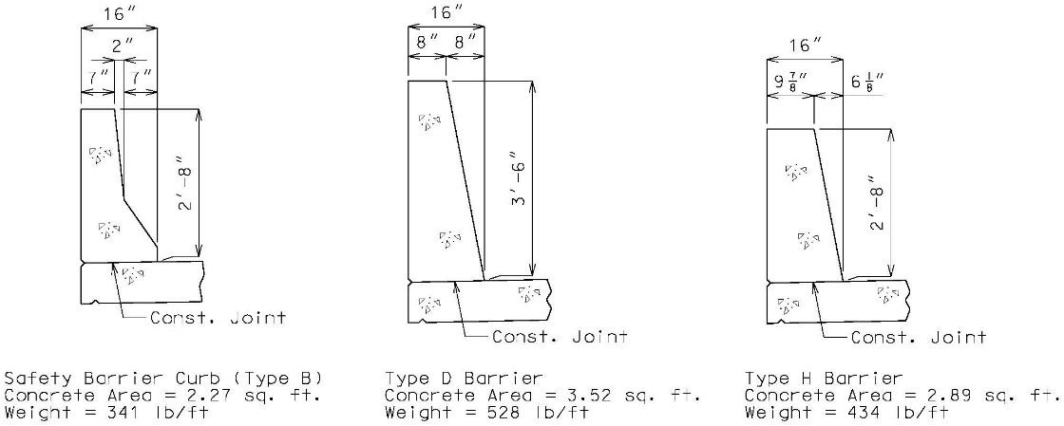

Type D Barrier
The Type D Barrier shall be used on all new or replacement bridge projects except where sight distance is a concern. The Type D Barrier is a 42” tall, single slope barrier and is identical in shape and reinforcing scheme to the current Barrier Curb (Type D) standard drawings. The Type D Barrier meets the height requirements for both MASH TL-4 (36”) and OSHA² (42”). The Type D Barrier has been reviewed by the Midwest Roadside Safety Facility (MwRSF) and is compliant with MASH 2016 TL-4. This assessment is applicable for continuous and discontinuous sections of the barrier.

The Type D Barrier shall be used on all redecks and rehabs where the full length of barrier is being replaced with exceptions for the following: 1) sight distance concerns, 2) rating concerns where the weight of the barrier prohibits its use or causes impractical restrictions or costs for the project.

Type H Barrier
The Type H Barrier shall be used, upon approval of the SPM or SLE, on all new or replacement bridge projects where sight distance concerns prohibit the use of the Type D Barrier. The Type H Barrier is a 32” tall, single slope barrier with the same front face slope as the Type D Barrier. MASH 2016 TL-3 requires a 32” tall barrier so there are concerns for future overlays. The Bridge Division feels that when sight distance is a concern, it is not practical to increase the barrier over 32”. The Type H Barrier has been reviewed by the Midwest Roadside Safety Facility (MwRSF) and is compliant with MASH 2016 TL-3. This assessment is applicable for continuous and discontinuous sections of the barrier.

The Type H Barrier shall be used on all redecks and rehabs where use of the Type D barrier is prohibited or causes impractical restrictions or costs for the project.

Safety Barrier Curb
The two-slope Safety Barrier Curb, also referred to as the New Jersey shape, shall not be used on new construction projects. This includes redecks and rehabs where the full length of barrier is being replaced. The Safety Barrier Curb may be replaced in kind where spot work is required (i.e., expansion joint replacements). For overlay projects, where the grade is not being increased more than 2”, the Safety Barrier Curb may be used in place as outlined in EPG 751.1.3.4…Common Bridge Rails (for Rehabilitations) table.

Curb Blockouts
Vertical curb blockouts will again be used to treat sub-standard railing systems. There will be a few modifications from past practice to improve the expected crash performance of the blockout.

A 36” height, measured from the top of roadway surface at gutter line, will be used as the preferred standard to meet the MASH 2016 TL-4 criterion. The end treatment for the 36” height will require a 6:1 slope to transition down to a 32” end height. A 32” uniform blockout height will be allowed, upon approval of the SPM or SLE, when either sight distance or weight restrictions are a concern. A 32” blockout does not require a reduced height for the end treatment. For overlay projects, where a curb blockout is already in place, the final blockout height shall not be less than 30”.

The current 3 ¾” block out used for guardrail attachments is considered a snagging concern for vehicle collisions. The new end treatment for the guardrail attachment will include a gradual width transition that approximates a 10:1 slope. See Development Section for further details.

- Additional Guidance
Joint Spacing
The standard joint spacing over intermediate bents shall be 12’-0”. This spacing will allow the full yield-line failure pattern to develop for Type D barriers. For simplicity, the 12’ spacing shall also be used for Type H barriers. For spans less than 40 feet, one transverse joint at centerline of bent is recommended, but the additional joints on either side of the bent are being eliminated. Otherwise, the criterion for using one or two joints on either side of the bent will remain unchanged.

Joint Placement Summary
For all spans use one joint at centerline of intermediate bent
- Span < 40 ft No additional joints
- 40 ft ≤ Span ≤ 125 ft Add one joint spaced 12’ on either side of bent
- Span > 125 ft Add two joints spaced 12’ on either side of bent

Deck Overhang Design
The loads for deck overhang design are not expected to increase significantly between the Type D and SBC. For documentation use the following values in your slab designs.

MASH 2016 TL-4 (Type D Barrier):
H = 42 in Rw = 79.1 kips
W = 16 in. Lc = 11.73 in
Mc = 12.37 k-ft.

Note: Assume the SBC and slab are continuous and the top transverse bars are fully developed at the gutter line.

- Future Guidance
Standard Drawings will be released for the Type H Barrier and curb blockout for curb and parapet or railing by April 1st 2020. Afterwards EPG guidance will be provided for the Preliminary Design, Protective Barriers, and Widening and Repair sections of the LRFD Bridge Design Guidelines. Various other articles in the EPG will require minor to moderate revisions as well.

Standard Drawings:
- Type D Barrier (BAR – renamed to remove the term “curb”)
- Type H Barrier (BAR - 4 new drawings)
- Curb Blockout (CBO – 6 new and/or improved)
- Various affected drawings (150+ drawings)

Engineering Policy Guidance:
- 751.12 Protective Barriers
- 751.1.3.4 Guidelines for Curb Blockout
- Various affected sections

¹ Prior to November 1, 2019 roadside devices were considered using the criterion set forth in NCHRP Report 350 “Recommended Procedures for the Safety Performance Evaluation of Highway Features”.
²Occupational Safety and Health Administration

